**WIRELESS WEATHER STATION with ARDUINO**

**Project Name:** IoT Wireless Weather Station (with Arduino)

**Project Type:** Computer Engineering License Program II. Term Engineering I Project Course Project

**Project Consultant and Team Coach:** Dr. Öğr. Üyesi Ö. Feyza Erkan

**Project Team:**

* Lütfi Can Köseoğlu (Computer Engineering I Department Class Student)

**Project Goal:** The aim of our project is to inform the user about possible weather conditions in advance and to eliminate the weather problems that the user will encounter during the day.

**Project Output:**

This project is a wireless weather station that has emerged to increase the quality of daily life of people and to minimize the rate that they will be affected by surprise weather conditions. The functionality of the project can be understood from the following items

* Measurement of ambient temperature, humidity, open air pressure, altitude and the amount of gases harmful to human health in the environment.
* Instant and average values ​​of the measured data are reported to the user both on the LCD in the system and on the "Thingspeak" website to which the system is connected.
* Instantly reported data is stored on Thingspeak server.
* 3-day weather forecast via Thingspeak server.
* Warn the user with a red LED in case the ambient air is unhealthy

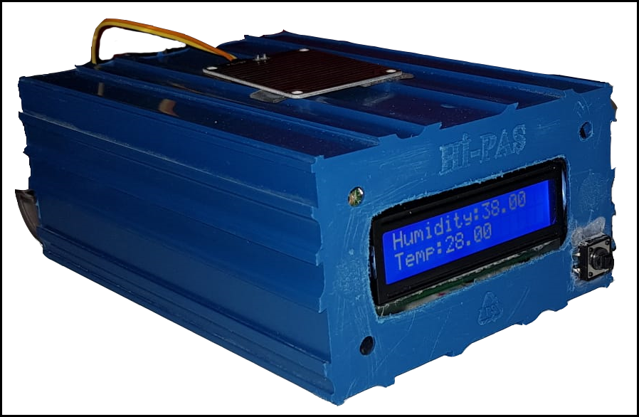

**Used Tools & Parts:**

* Arduino Mega 2650 R3
* DHT11(Temperature & Humidity Sensor)
* BMP180 (Air Pressure Sensor)
* MQ135 (Air Quality Sensor)
* Rain Sensor
* ESP8266 (Wifi Module)
* 16x2 LCD Screen, Button, Red Led Light, 7-Segment Display
* Thingspeak

**Areas For Development:**

The weather forecast can be projected from the LCD screen on the top of the system.

By adding a wind turbine, instant wind direction and power can be reported to the user.

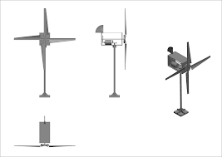

**Commercialization Potential:**

This project stands out with its feature of informing the user about instant and possible weather conditions. In this respect, it is a product that will benefit many people and has a high commercialization potential.